**GitLab**

1. Open the GitLab URL <https://code.cognizant.com/>
2. Login to GitLab using CTS Network UserID and Password

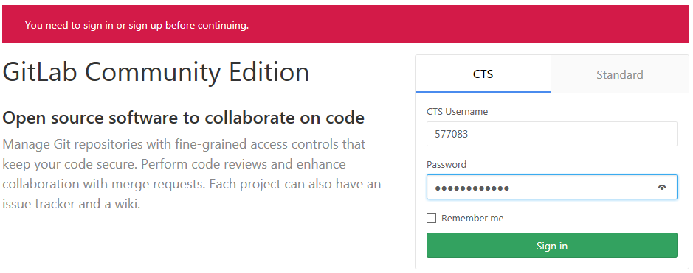

1. Click New Group, it will help to manage projects and members

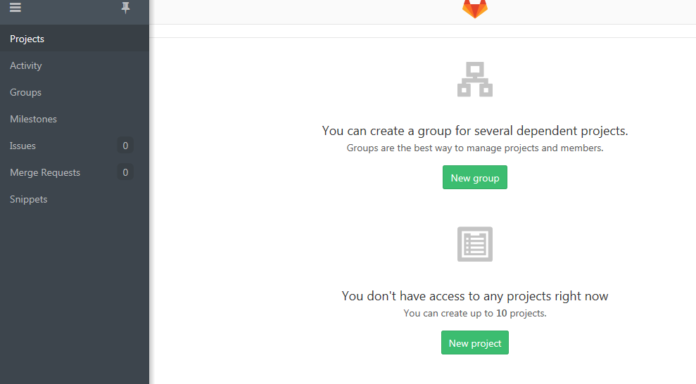

1. Enter the below highlighted details to create a Group: Name, Description, and Visibility

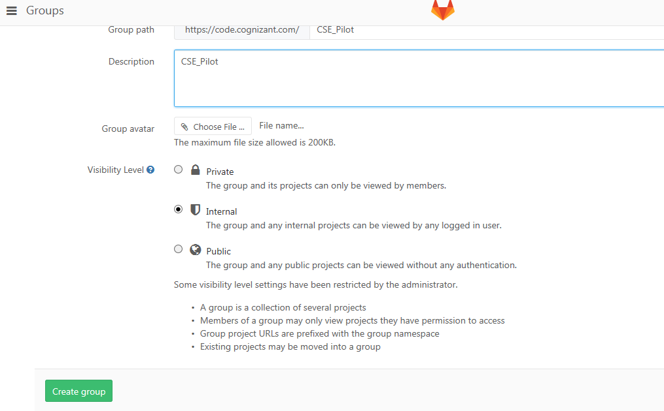

1. Below screenshot for Created a new group

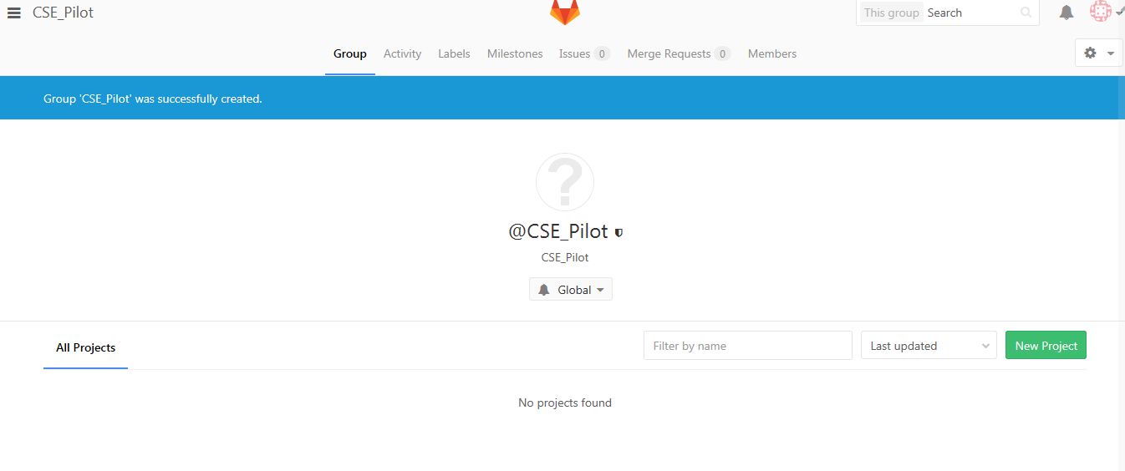

1. Click New Project option to upload the Associate code and Enter the below highlighted details to create a Group: Name, Description, and Visibility

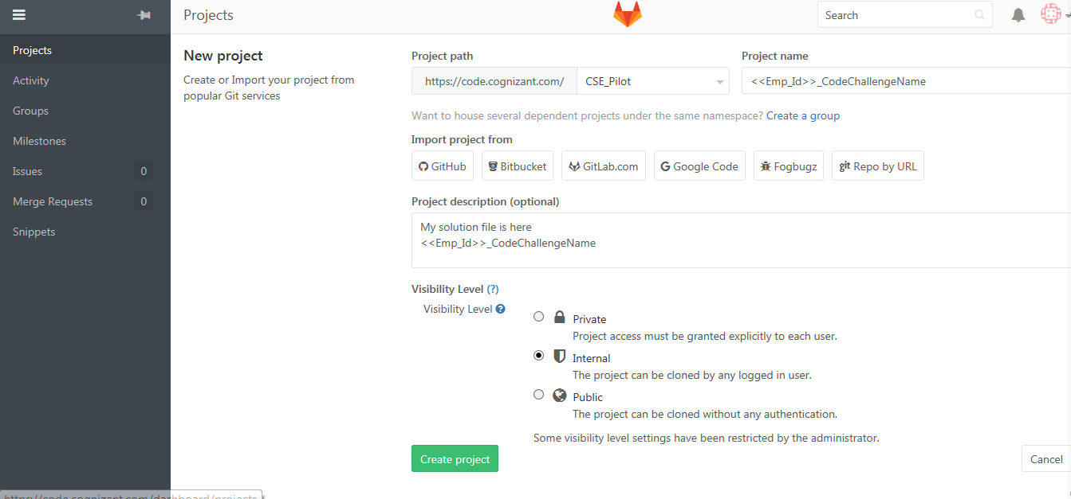

1. Below screenshot for Created a new project under the Group

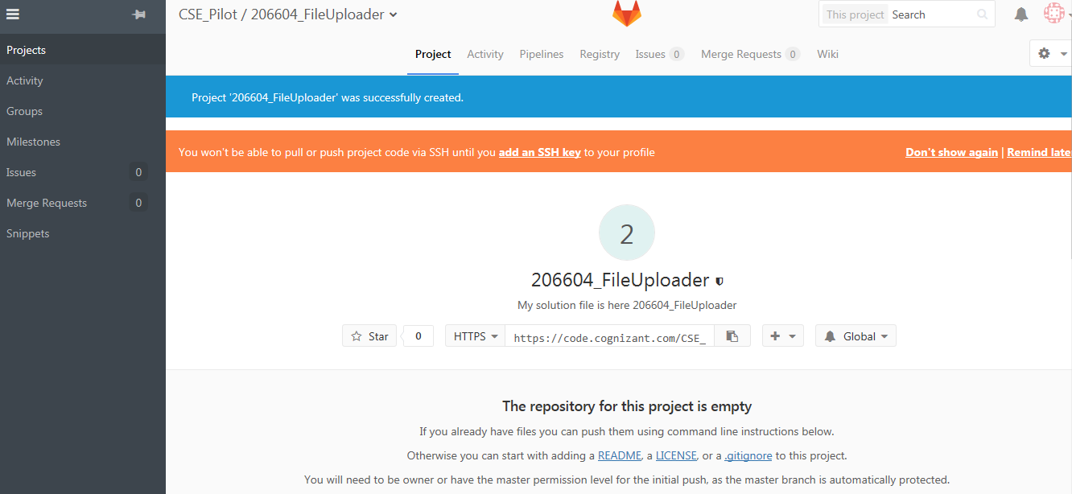

1. Click on READ ME option to add the your comments regarding the project completion and to upload the solved case study as shown below:

*Please note: As the repository for this project is empty, we need to add a READ ME and only then we can upload the solved case study*

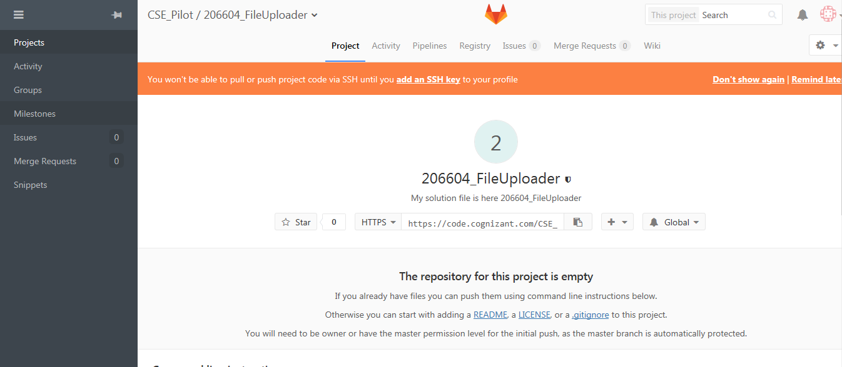

Read Me file details to be updated as shown below:

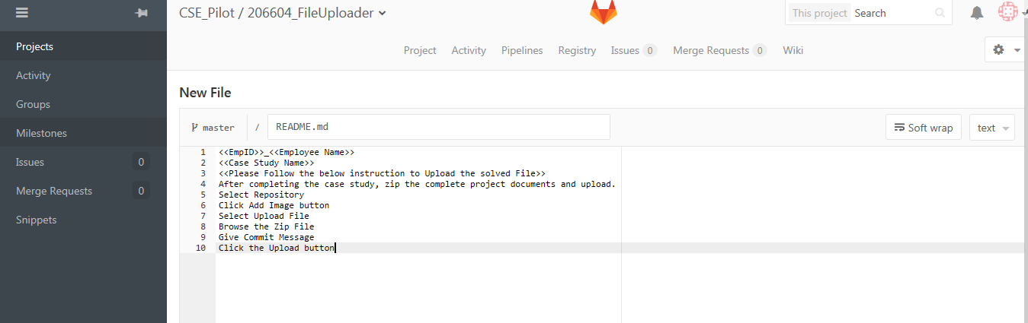



1. Provide Member access to each associate for their folders

Go to Settings 🡪 Click on Members

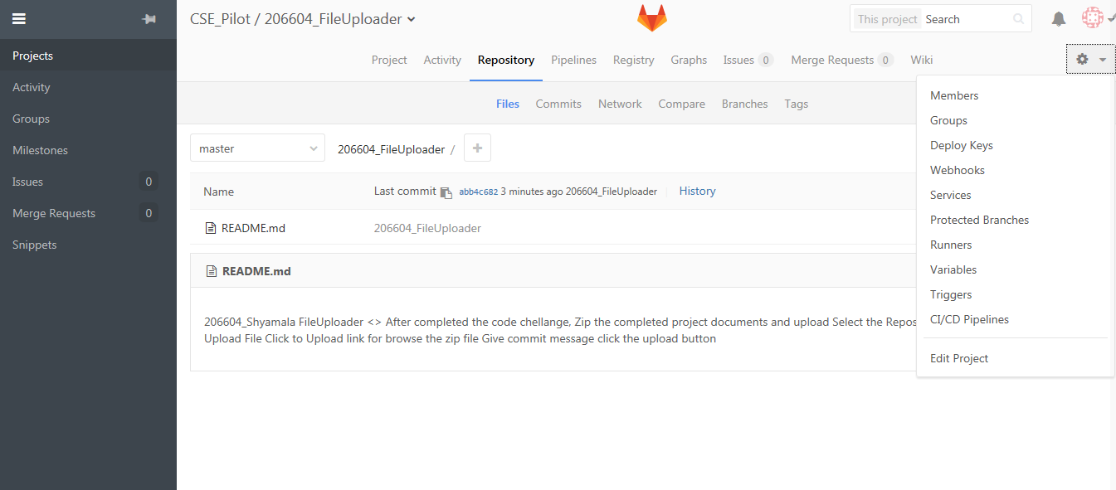

Add Associate id, Role and Expire Date for this project and click add to project

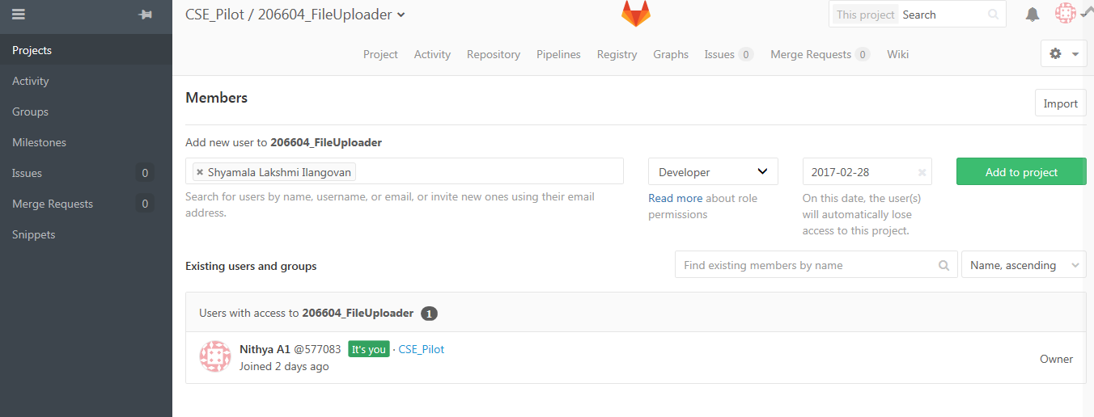

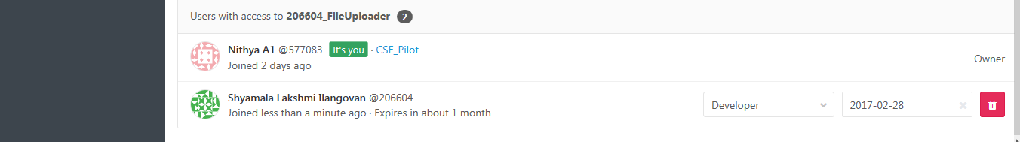

1. Restrict associate not view others project details

Go to Settings 🡪 Click on Edit project

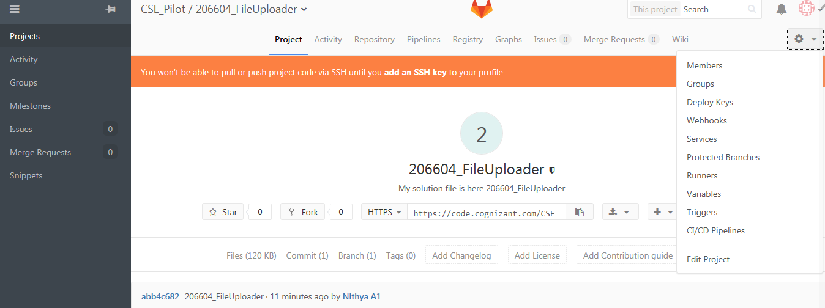

Change the Feature visibility as only team members as given below and Click save Changes

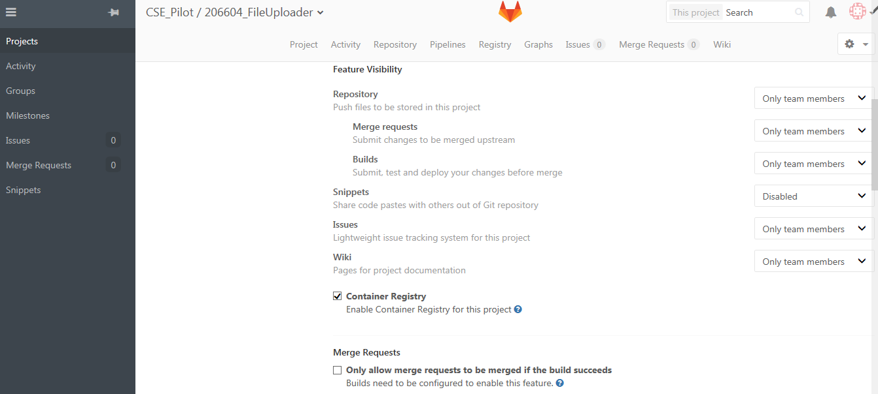



1. After Associate completes the solution upload, Admin can download the solution using the download option

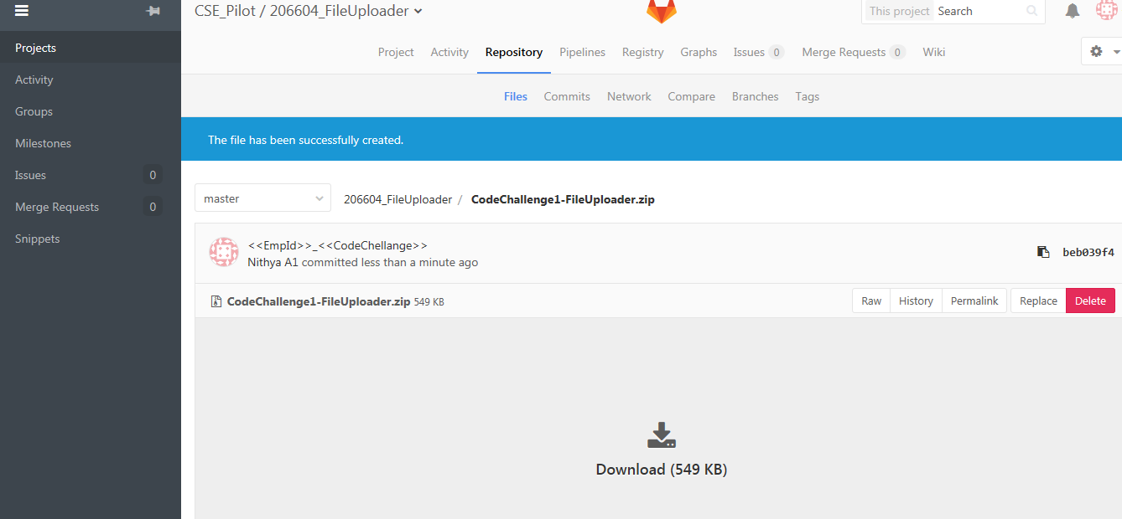

Associate View

1. After completing the case study, zip the complete project documents and upload. Save the Zip file in the following naming conversion <<EmpId>>_<<CodeChallengeName>>.Zip

Example: 577083_FileUploader.Zip

1. Login to : [https://code.cognizant.com/<<GroupName>>/<<ProjectName](https://code.cognizant.com/%3c%3cGroupName%3e%3e/%3c%3cProjectName)>>
2. Below screenshot shown

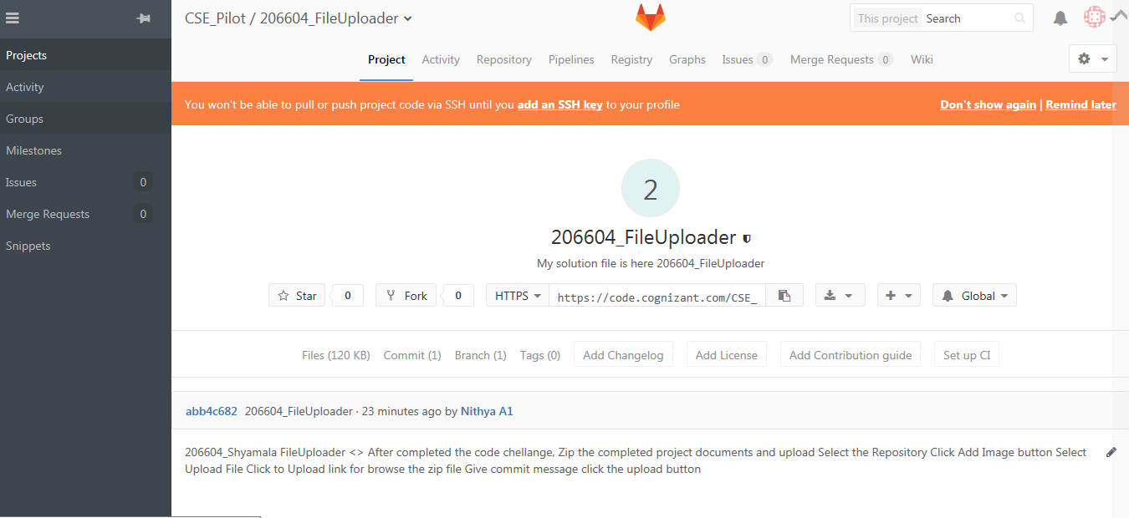

1. Click on the Repository

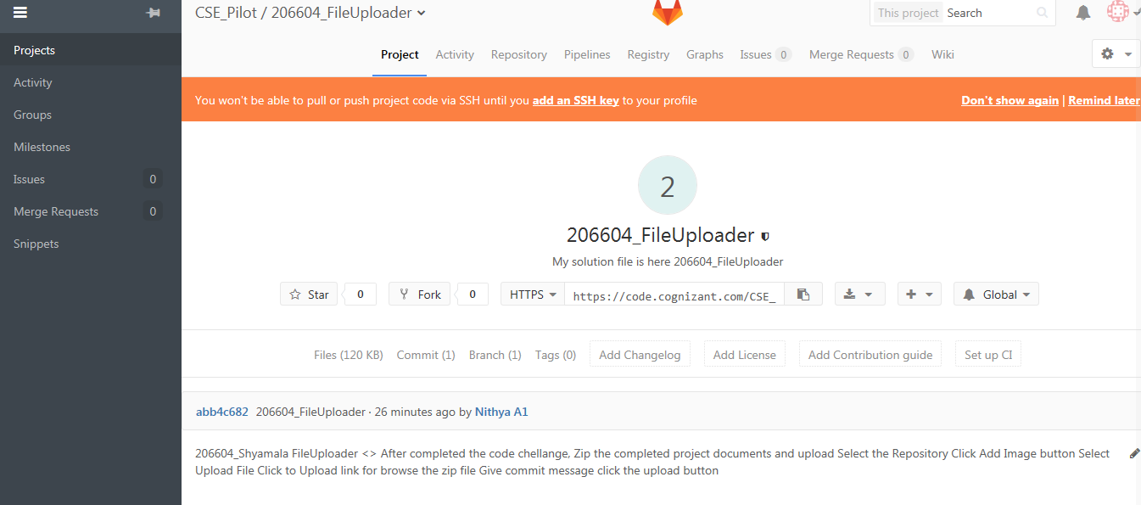

1. Click Add Image and select Upload file

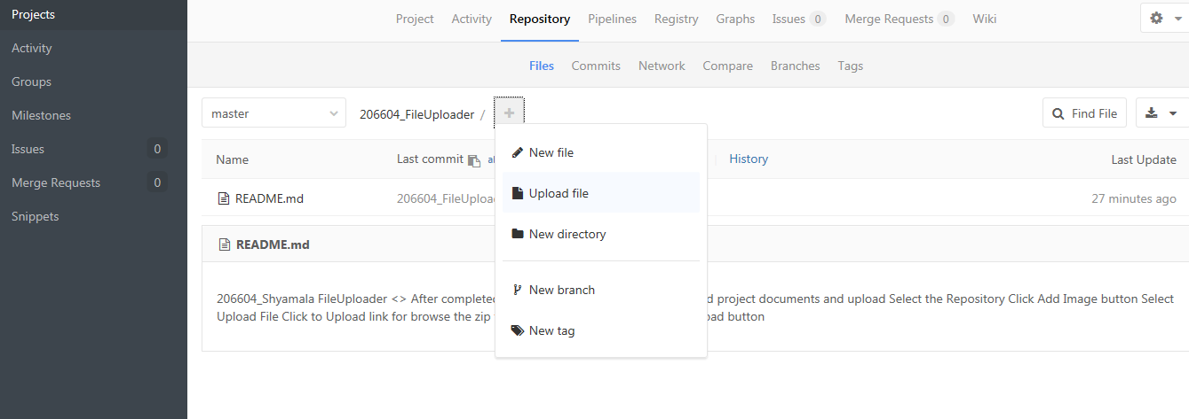

1. Browse the Zip file on clicking on click to upload and Upload

